**CS604P Assignment #2 Spring 2023**

Name: Abdul Rehman.

VU-ID: BC220424444.

**Solution:**

**Source Code in C:**

/* Abdul Rehman

BC220424444 */

#include<stdio.h>

#define PAGE_SIZE 1024

#define PHYSICAL_MEMORY_SIZE 4096

void simulate_memory_access(int page_number){

static int physical_memory[PHYSICAL_MEMORY_SIZE / PAGE_SIZE] = {0};

static int page_table[PHYSICAL_MEMORY_SIZE / PAGE_SIZE] = {0};

if (page_table[page_number] == 0){

printf("Page %d is not in physical memory. Page fault: \nPage %d loaded into physical memory. \n", page_number, page_number);

page_table[page_number] = 1;

}else{

printf("Page %d is already in physical memory. \n", page_number);

}

}

int main(){

simulate_memory_access(0);

simulate_memory_access(1);

simulate_memory_access(2);

simulate_memory_access(0);

simulate_memory_access(3);

simulate_memory_access(1);

simulate_memory_access(2);

simulate_memory_access(4);

simulate_memory_access(8);

simulate_memory_access(3);

simulate_memory_access(2);

simulate_memory_access(1);

simulate_memory_access(4);

return 0;

}

**Code File Screenshots:**

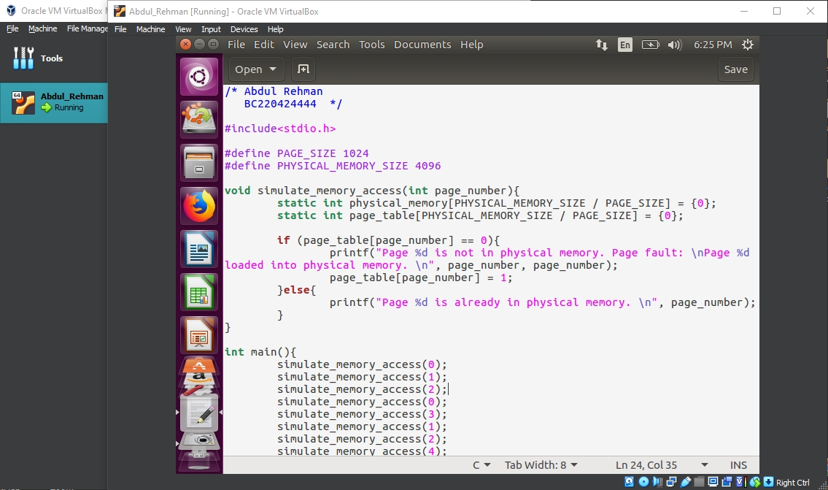

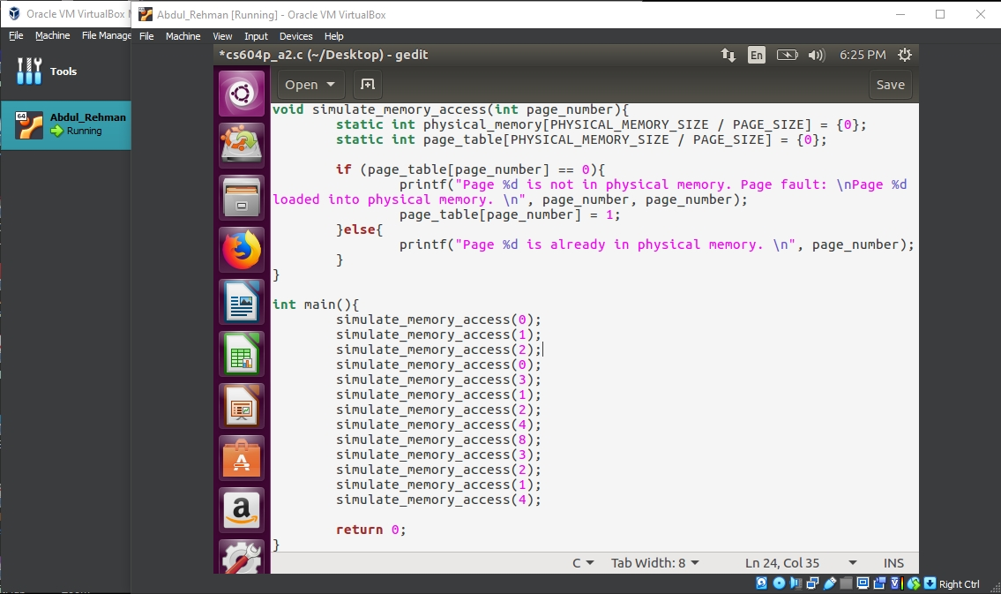

**Terminal Output Screenshot:**

